Louisiana Federation of
Music Clubs

Organized and Affiliated with NFMC Since 1928

Irene Vile, President

Summer/Fall-2010

Dear Federated Friends,

I know as one ages, ones taste matures. I’ve always told my children they would know when they reached adulthood because they would love asparagus. One of the things I have come to enjoy in my maturity is sharing information with you on the written page. Writing would have been something I would have avoided like a case of chickenpox, even into my early 40’s. But, LFMC has given me the opportunity to grow in so many different ways that I really would like to be able to give each of you a glimpse into the life of a Federated State President. This newsletter will be purposefully different. If you are the type who just wants the dates, deadlines, the necessary information, then your best bet is to visit the LFMC web site: www.lfmc-music.org. But, if you are the type who likes to read your sister’s diary and pretend you are right there with her, to get the inside scoop…well….. you’re gonna love this!

APRIL
Journal Entry:
April 5th
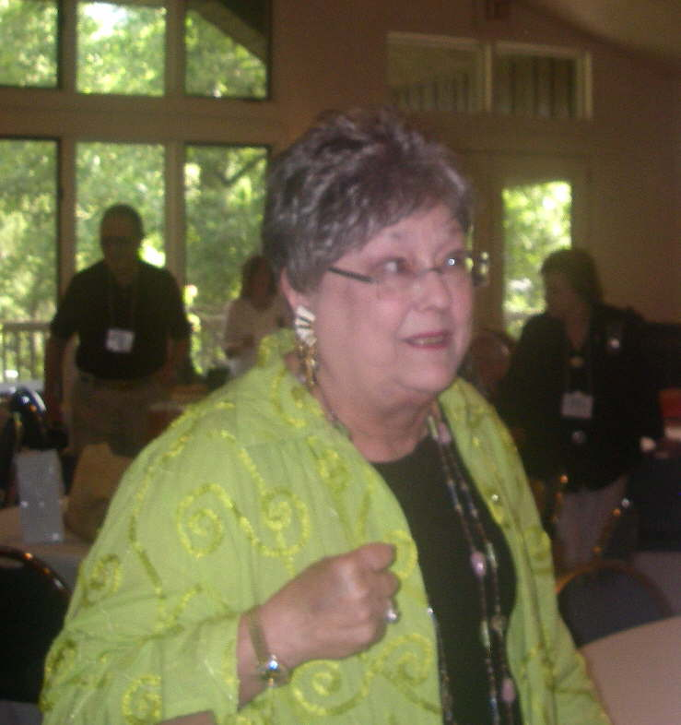
How did I get myself into this?… Oh yeah, I remember, I walked up to talk with Melanie and Joy at Festival (03 or 04??). They were having a discussion about who they might be able to nominate for a Vice President. They needed a whole slate of officers. I said I’d do it. They said, “It would put you on the track that eventually MIGHT lead to becoming the State President”. But, I’m thinking, if Dottie took 2 terms (4 years), and Ruth took 2 terms (4 years), with the company talking about moving, then by that time I wouldn’t be in the state. I came home and told Mark he had 8 years to get me out of Louisiana. So, it’s Mark’s fault we’re still in Louisiana even after Katrina! Okay, Irene, get a grip here. Yes, it is your first convention as president, but you know those folks in Baton Rouge have got everything under control. When Baton Rouge clubs do something, they do it well! Dottie Smith and her committee have things all lined up. Everything is all set, official call is out, honored guest, Beth McAuley NFMC Vice President Southeastern Region, is taken care of, printed program completed. All you’ll have to do is walk in, get the business taken care of and try to keep things on schedule. Yeah, but…going to this shorter 2 day convention, it is going to be really hard to get through all the business. Settle down, stomach! I really need to quit talking to myself. I need to call Melanie.
Beth

April 11th
I was so tired last night from convention, I couldn’t eat. But that’s okay, the Luncheon at the hotel was fantastic so I’m not going to starve – might even lose a couple of pounds. But, it really was a great convention. This is a good kind of tired. Kay Hawthorne just amazes me. Here she’s got 40 to 50 people over to her home for a delicious sit down dinner and her dishwasher breaks down in the middle of it. She’s cool, she’s calm (I’d be freaking out), such a gracious hostess. The entertainment was so good, this weekend, both Friday evening and the newly added short musical interlude Saturday morning. It was the singer Saturday morning that really got to me. She’s singing away, and I start tearing up. I mean, they’re running down my face. I thought it must be a let down from the stress. But then I began to hear other sniffles all around me in the audience. Tears shed remembering the separation from loved ones. There were many tears from that song. Of course, it had to be Danny Boy. Shared tears are precious, they bind us together, and I will never listen to Danny Boy again and not think of that morning and my friends’ tears. I’m tearing up right now, even! Music is powerful - it touches the soul….It took several comments over the 2 days to realize Beth was in a serious battle with reoccurring cancer. Her thoughts shared with us as guest speaker are all the more relevant. I noticed Jeanne seemed more tired this convention. How many conventions have we been roommates?? Alexandria, Shreveport, Lafayette, Natchitoches, Baton Rouge. She’s a good roomie. She’ll be 91 in October. She keeps saying she wants to make it to 100. She just might! She would really like us to find a replacement for her position as Liability Chairman.
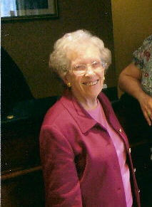
Well, we managed to get most of the business finished even considering the Board gets together to conduct business just twice a year, Convention and Fall Board meeting. Very seldom is there business that must be taken care of by email. It amazes me this organization functions as well as it does. I’m not happy we decided to reduce a few more of the state awards, but considering how our investments are doing in this economy, it was probably wise. We also combined the positions of Vice President and President Elect. We couldn’t find anyone for the Vice President position anyway. We did vote to have all the Club Presidents serve on the Board of Directors. Hopefully, this will encourage some to become more involved in the decision-making process that will affect their clubs. The really positive aspect of this convention was almost double the attendance from 2009. We must impress every member that without a functioning state organization, Federation will cease to operate in Louisiana. We must have more participation on the state level!!!

April 12th
Ana Kearns called today. She was in an accident, rear ended at 60-miles an hour, traveling 1-10 on the way back to Thibodaux from convention. She’s stiff and sore, but nothing was broken, except her car. The Lord was gracious to her and us! Thank you, Lord!

April 23rd.
Hmmm… where are my trophies? They should be coming in this week or next.
April 28th
I don’t think the trophies have ever been this late. I wonder if there is a problem?

MAY
May 3rd.
It’s time to make a few phone calls about this trophy issue. … Well, that seems to have taken care of things. Trophies should be on their way.

May 10th
Still no trophies, my recital is Saturday…this is really not good! More phone calls, more promises, more excuses.

May 21st
Well, Melanie and I have our trophies, not in time for our recitals, but they are finally here. We WILL get to the bottom of this mess in Pittsburgh. Since Melanie and Kay both serve on the NFMC board of Directors they can dig into this mess from that angle. I will be bringing this up in the State Presidents Council meeting, too!

May 24th - 28th
How did folks function before email? This week the emails are flying back and forth. Things are really kicking into high gear as Louisiana makes its plans to host the NFMC Southeastern Regional meeting at the Brevard Music Center, NC. This responsibility comes around to our state about every 9 or so years. Kay, committee chairman, has chosen the theme for our weekend to be tied to the musical Kismet. Melanie is working to get the Official Call out to the 13 states, Ken Nelson is working on the program for the weekend. Janelle Couvillon is helping on centerpieces, and will be performing the different songs. I’ve got to get the cover letter ready for the Call…. more writing.

JUNE
June 1st
VACATION!! Just a very few students taking lessons, one committee meeting to finalize plans for the Brevard weekend , and one week of VBS at church. Maybe I’ll get the wallpaper stripped and the walls painted in the foyer this month.

June 8th
After talking with Lynette this morning, it’s become apparent she just can’t fulfill all the duties of the Treasurer’s job. I accepted her verbal resignation and began the process of notifying the Executive Committee and Board of Directors. Once again email was a godsend in relaying information and handling the voting procedure necessary to install Randy (bless him for being willing!) back as Treasurer. At the time I didn’t realize the bank would require updating filing with the Secretary of State. I’m not exactly sure what will be needed??? Minutes of meeting where Randy is re-elected as Treasurer, well we’ll have to do that by email. I’m thinking the state will want an updated copy of the Constitution/By-laws. We’ll probably have to have something “official” stating the Officers of the State. Our checking account is not going to be accessible until all documents are provided. Oh boy! Are we having fun yet?!!

June 18th
Kay and Janelle are coming down from Baton Rouge and Melanie is coming over for a Brevard Committee meeting. I gotta make blueberry muffins and have the coffee on. Mark will need to teach me how to use this new coffee maker – it’s high tech! Kay’s ideas are really good. We have to decorate around the Kismet theme. Janelle will sing 3 different songs at the 3 different meals: Baubles, Bangles and Beads (Sat. Luncheon), Stranger in Paradise (Sat. evening Banquet), and Sands of Time (Sun. Luncheon). We’ll need tons of Mardi Gras beads for all 3 meals. A Gift Basket (my job). Ooooo! I’d love to rig up a flying carpet. We all went to JoAnns and then out to eat lunch –yummmmm.

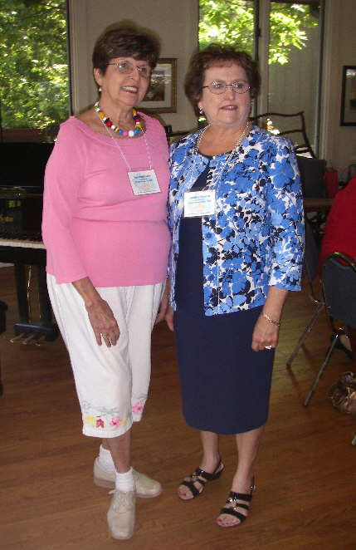
June 24th
LIST: Got the carpet, already had the tassels. Mark has gotten into this! He’s figured out a way to use coat hangers, bent and inserted into the edge to make the carpet fly. I could use my bedroom curtains to make a tent effect and got the Louisiana food items for the gift basket.

June 29th
Phooey…Kay just heard back from Brevard. There’s no way to hang anything in the room we’ll be using. Nix the idea of the flying carpet and tent affect. Well, at least I can use the carpet in the foyer, when I get that wallpaper off and the walls painted!!!

Kay & Janelle
JULY

July 8th
Car packed for 2 week vacation – Mark and I are so ready for this! Mountains here we come.
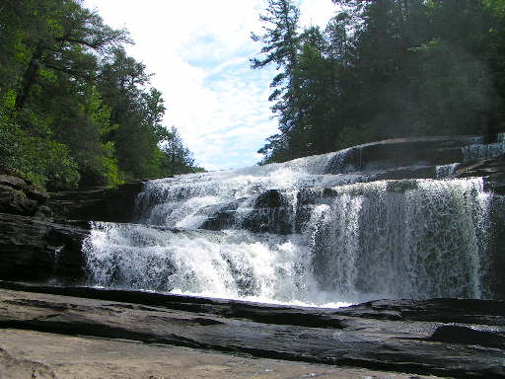
July 9th
Arrive Brevard, NC: Mountains, rivers, waterfalls, I’m drooling…Check into hotel, drive over to the music center, Friday night box lunch, delicious! Wonderful production of Die Fledermaus by the Janiec Opera Company and the Brevard Festival Orchestra. I can’t believe there are kids playing in that orchestra.

July 10th
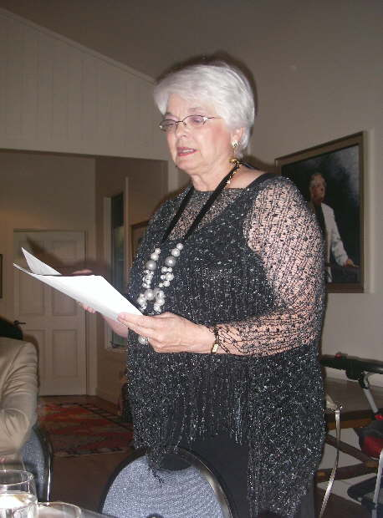
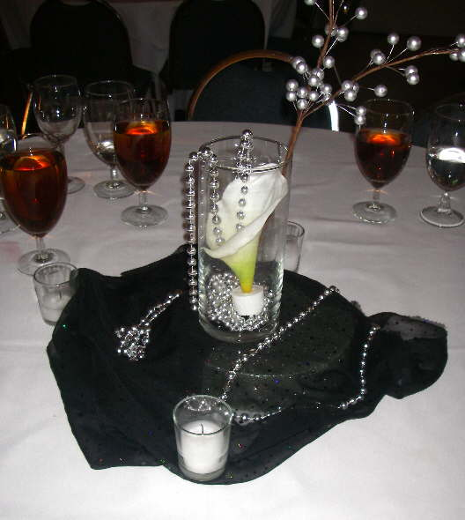
Goodie bags are a hit. Not only did they have the usual stuff, but the cookbook and Zapps potato chips were a real nice touch. Meetings gave an update on the progress of Bucks for Brevard. This effort to establish an award from the South Eastern Region is really taking off. The goal was to raise $25,000 in five years. We are at $14,500 and it’s just the first year. There is a project of selling packages of note cards with the profits going toward the award. (See additional attachment.) I got to give the Welcome for the Banquet tonight. After confessing I really can’t speak Cajun French, even though I greeted the general assembly in French last year in Orlando, I gave them a real lower 9th ward “Where ya at Dawlin’”. The white Calla Lilies on the black background with silver beads look so elegant. Carolyn Nelson, NFMC Vice President was the honored guest speaker. It was very nice to be able to get to know her in a smaller setting. After Lana Bailey completes this year and her term of office comes to an end, Carolyn will become the next NFMC President. She is a very interesting lady, and I have no doubt NFMC will benefit from her insight and experience. The concert tonight with conductor Keith Lockhart and the Brevard Center Orchestra featured Overture to Don Giovanni, Mozart, and Ein Heldenleben, Op 40, R. Strauss with Piano Concerto in A minor, Op 54, Schumann, Joseph Kalichstein, piano. Wish I could play like that!

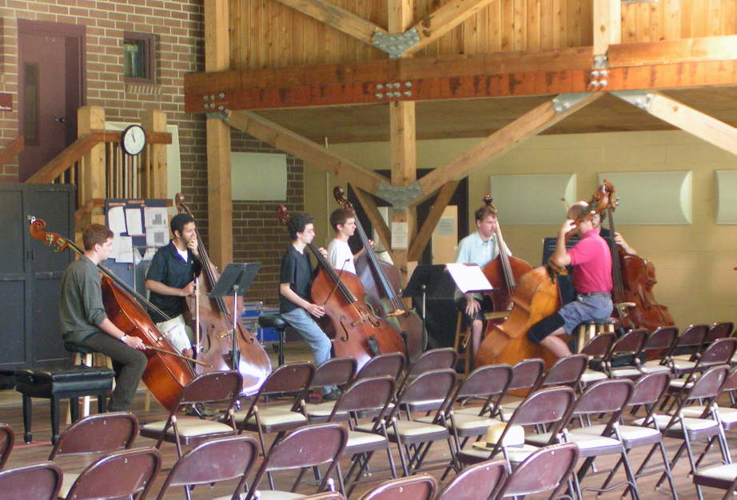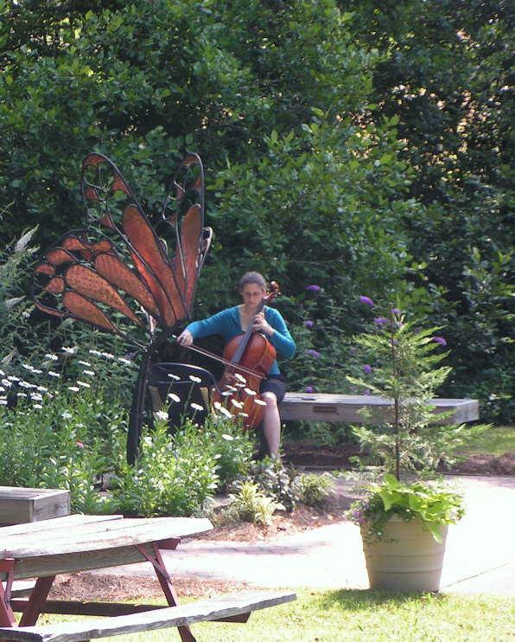

July 11th
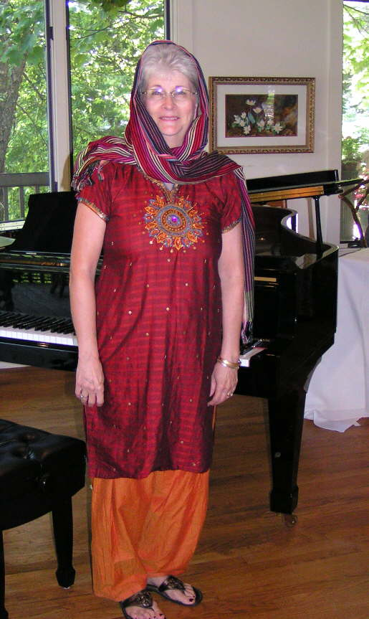
It’s Sunday, last day, the final luncheon. My job today is Mistress of Ceremonies for the luncheon. This is something else I’ve NEVER done! Just get through introducing the head table. I’m glad my friend had this Indonesian outfit. I can’t remember what I said exactly, but I remember using words like “esteemed, venerable, sage, trusted steward”. I just tried to talk like they did in Aladdin, in keeping up the Kismet theme. In the concert this afternoon Keith Lockhart conducted the Transylvania Symphony Orchestra in Symphony No. 1, by Brahms, and the Piano Concerto in A minor by Grieg featuring James Cockman, III, NFMC 2009 Young Artist, pianist. We really need to find a way to promote the Young Artist awards in our universities. Louisiana has had Young Artist winners before, but it’s been awhile…


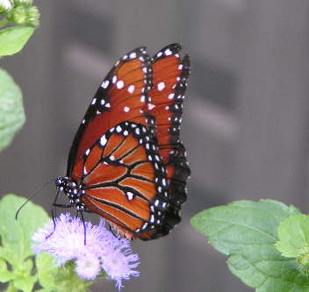
This past weekend has been very enjoyable and definitely a “perk” for serving as State President. But, I can’t help but wonder if the cost to LFMC outweighs the benefits. What are the benefits? Well, Justin Moore, trombonist from LSU, was awarded the Lucille Parrish Ward Award. He performed in the orchestras. I’ve decided Brevard doesn’t benefit LFMC, and truthfully, LFMC is small potatoes to Brevard, BUT… if LFMC can play a part for one, two or maybe even three students to have the experience that Brevard offers, then it’s more than they would have open to them in our state. Our participation helps to get them there!

July 12th
Arrive Maryland to see grandkids.

July 17th
Arrive Michigan to see Mark’s mom.

July 24th
Arrive Metairie – home again, home again jiggity jig. 2,800 miles in a car. Just Mark and me, we’d do it all again in a heartbeat! I’ve got one week and 2 days to get ready for the national convention. Wash clothes, clean house, take care of plants, check with Jeanne to see how things are going with the liability insurance, check with Randy to see if we have access yet to the checking account, and write a report! More writing…wallpaper still in foyer...


AUGUST
Aug. 3rd
Melanie and I are on our way – Pittsburgh – NFMC Convention

Aug. 4th

Where’s the smog? Ain’t there no more! Pittsburgh is really a beautiful city- rivers and bridges. I feel right at home. Meetings, Workshops, Luncheons/Dinners with speakers, and Concerts from 8:00AM until 10:00PM. Did you notice they scheduled time for taking the food in, but they didn’t schedule any time for getting the food out!? I’m sure there must be some appropriate committee chairman to bring this issue before. This first full day Melanie, Kay, and I signed up to take the tour of the city, an Organ Concert in St. Paul’s Cathedral, Dinner in the basement, but they don’t call it a basement (there is a special name for it), and an evening cruise on the 3 rivers that intersect in Pittsburgh. It was very tiring, but such a nice time. There are so many new faces, so many new friends.

Aug. 5th - 8th
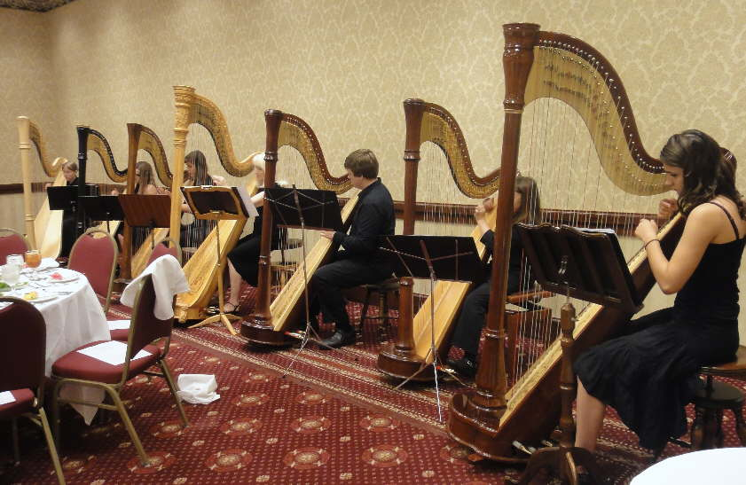
Meetings - Council of State Presidents (2), Festivals, Junior Division, Board meetings, for Melanie and Kay, they even had one on Sunday morning! Budget, Finance, Division meetings and sometimes meetings overlap, so we split up and go to different ones. Workshops – My favorite was the one on Course of Study, but the Collaborative Piano was excellent too! I skipped the Handbell workshop to go swimming. I’d been sitting too much. The Mature Voice was very good with lots of tips. The Parliamentary workshop is a MUST every year. Dr. Eugene Bierbaum does a wonderful job making parliamentary procedure fun! A Beethoven workshop, a Composition workshop, and Jeanine Yeager presented “Strong Gifts with Strong Limitations”. She has some thought provoking techniques to help non-readers Luncheons - Thurs.-South Eastern Regional, Barbara Hildebrand, 10 min. before going in says, ”We’re going to do a skit for Bucks for Brevard. We’re going to call all the state presidents, you tell how you’ve hunted for “bucks”; oh yes, by the way, try to make it funny”. Let’s just say WHAT HAPPENS in Pittsburgh, STAYS in Pittsburgh. I haven’t even let Mark see the pictures yet. I’m hoping it doesn’t show up on Facebook. Saturday’s Luncheon honors the Rose Faye Thomas Fellows. Those who have contributed funds (I think it might be $1,000) to this award all wear special medals. During this luncheon the new inductees are presented their medals. It’s always touching. Beth gave the funds for her sister, Jimmy. There’s a real story there but I don’t have enough room. Wives are sometimes surprised by the husbands. Concerts – Duquesne University Jazz Combo, Northern Light Flute Quartet (I’ve never seen a bass flute before - weird), Westminster College Faculty Brass Quintet, Young Artist (‘09), Daniel Seigel, baritone, Music by 6 Harps, American Festivals Chorus, Duquesne University Tamburitzans Alumni Dance Group, Young Artist (’83) David Allen Wehr.

August 8th
Whew! Home again… So what did you find out about the Gold Cup mess, Irene? Well, we weren’t the only ones complaining. North Carolina, Florida, a couple of other states also had ISSUES. After attending 3 different meetings, hearing the Gold Cup Chairman speak, Festivals Chairman speak, having private conversations with Gold Cup chairman and Jennifer, here’s the scoop:
Kay is calling it the “Perfect storm event” and it really was. What went wrong:
1. The manufacturer could not find a banking institution willing to give them a line of credit to pre-purchase supplies. (“It’s the economy, stupid.”)
2. Jennifer, NFMC Administrative Manager, was on Maternity Leave and her co-worker was overwhelmed with Festival orders and Bulletin orders. Co-worker was not properly trained to take over.
3. Problems with our own LFMC Treasurer.
4. Problems with some Festivals Chairman taking weeks to resolve errors in their reports.
5. Problems getting bases for trophies from China.
6. Flooding in Nashville, trophies delayed in warehouse.

How NFMC plans to deal with this issue this year:
1. Manufacturer has been notified they have been placed on a one-year probation period.
2. Manufacturer already has bases on hand to fill the 2011 orders.
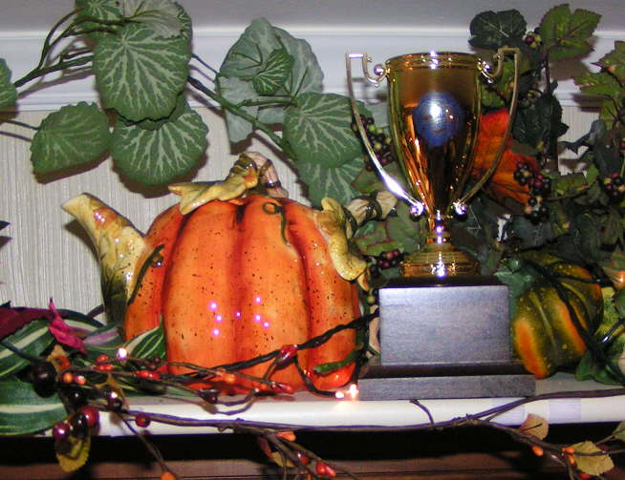
3. Jennifer will personally oversee and handle LFMC orders.
4. NFMC is willing to take bids from other vendors, but there is no interest in having multiple vendors. This has something to do with maintaining control over the copyright of the logo.
5. I received conflicting info about whether NFMC would release the use of the logo. Most of those I talked with said they would not release the logo for use.
6. They will look into possibly using hollow bases in place of the solid bases to try to bring down shipping cost by reducing the weight.
7. Shipping costs are going up dramatically! NFMC is in negotiations right now.
8. LFMC will continue to remain in the NFMC Gold Cup program. This is absolutely necessary so that students points will continue to accumulate AND be able to transfer to other states should child move out of Louisiana. Purchasing alternate trophies to either save money on trophies, shipping, or to support local businesses would cause Louisiana’s Juniors to lose their official NFMC points.

Almost forgot about the development of the national database: A Texas vendor has been chosen. NFMC is in contract negotiations. They are expecting to begin field testing with selected states possibly by 2012. It was stated that to be able to track a student for 12 or 13 years, a teacher would be required to submit the child’s full legal name plus birth date. This database will track correct level advancement, points earned, correct correlation between solo/ ensemble levels, additional points for concerto events, and I imagine even more.

I believe we are beginning to see a trend where NFMC will be taking over some of the record keeping that in the past has been the responsibility of the local club or the state organization.

Aug.9th
Time to start teaching my full studio, summer vacation time is over. I’ve got to get all the info from convention ready for Fall Board Meeting. Yeah!! We have a checking account , again!!!!Thank you, Randy!!!

August 21st
5:00 AM –Rise and Shine - Meet Melanie at 6:15, I sure do appreciate her driving! Pick up Jeanne in Gonzales 7:00 Hook up with Joy, in Baton Rouge. – Arrive Opelousas 8:30AM.-FALL BOARD MEETING

Meeting called to order: 9:10
Club representation (5 total): Music Club of Baton Rouge (6) - Randy Smith, Kay Hawthorne, Mary Lou Von Brock, Mary Nott, Wesley McCoy, Ellen Bordelon; Metairie Music Club (3) - Joy Harvey, Melanie Perez, Irene Vile; Ascension Jr. Counselors (2) - Dottie Smith, Jeanne Veron; North Shore Music Club (2) - Kathy Martin, Angel Carter; Acadiana Jr. Counselors (1) - Eugenia Hagood.
Total in attendance: 14

See attachment for Agenda - one additional item was added to New Business:
Minutes from Convention read and approved
Treasurer’s Report given and approved

Business Accomplished:
1. Investment Chairmanship established under the Finance Division. Wesley McCoy was appointed as
chairman.
2. $240,000 invested in selected Vanguard funds, $30,000 in checking account. Expenditure receipts will be kept by individual and treasurer will use “BillPay” for reimbursement. Three authorized agents selected for doing business with Vanguard.
3. Person will be hired for Data entry to produce Directory- $200 has been approved
4. Brevard Report given: Kay Hawthorne Bucks for Brevard now stands at $17,000.
5. NFMC Convention Report given: Melanie Perez
6. Nominating Committee will be comprised of all Past State Presidents, with immediate Past State President serving as Chairman.
7. Endowed Award Amounts have been raised to their original amounts, not their highest amounts. These amounts are subject to change in January after re-evaluation of final 2010 quarterly earnings.
8. Melanie Perez to be National Board member from Louisiana. Kay Hawthorne submitted to National Board at Large member awaiting voting done by National.
9. Education of terminology necessary:
Senior Club: There are currently 19 Senior Clubs throughout Louisiana. These clubs are varied in their make-up and their activities. Some meet every month, have musical and or educational programs, others meet once or twice a year, mostly for the purpose of Festivals. All adults must be a member of a Senior Club. Adults participating in Festivals events must be a member of a Senior club.
Club President: Person serving as head of your local Senior Club, also serves on LFMC Board of Directors.
Area Festivals Chairman: Person overseeing local area Festivals.
Junior Counselor: A teacher with a studio participating in Junior Federation activities, i.e. Junior Festivals, Essay Contests, Composition Contests, National Music Week activities, and other Awards.
Junior Clubs: Students in your studio who have paid their Junior Dues to participate in activities. Junior Clubs have specific names: Virtuosi (mine), Benchwarmers (Melanie), Joyfuls (Joy)
10. Location of LFMC meetings will be moved back to Baton Rouge.
Juniors: Students who have paid their Junior Club dues.
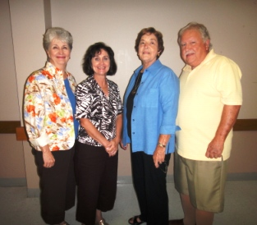
MEETING Adjourned

August 26th
Time to get started on another newsletter….more writing

August 27th
I need to get started on that newsletter

August 28th
I really need to start that newsletter…

August 30th
Jeanne spoke with Anna Kearns about taking over the Liability Insurance. She agreed. Thank you. Anna!
Irene Joy Dottie Randy
August 31st.
Summer over, old wallpaper still up in foyer…..I really, really need to get going on that newsletter

SEPTEMBER
Sept 1st.
I’ve been married 43 years…..whoa!
Sept. 3rd
I have a different idea for that stupid newsletter…..think I’ll run it by Melanie.
Sept. 4th.
Fall has been declared in the den! Pumpkins are out! I know, I’m stalling on the newsletter!!!!!
Sept. 9th
Email received from Randy: Jeanne’s in the hospital, she took a fall, but also had small heart attack. Not doing well…

Sept. 12th
NEWSLETTER ALMOST FINISHED – except for pictures. I’m going to need Mark’s help with that!
Sept. 15th
Jeanne’s been moved to: Baton Rouge General: Rm 488.
3600 Florida Blvd
Baton Rouge, LA 70806.


\UPCOMING DEADLINES:

1. November 1st: Deadline: Senior Club dues: Please help Randy out by submitting dues either by computer or typewriter. As we age, the handwriting becomes unreadable. u’s look like a’s. c’s look like e’s, r’s look like v’s This will be the last year reports will be accepted hand written. Starting in 2011, all Dues, Senior and Junior, will need to be submitted via computer.
2. November 1st. Deadline: Junior Club Dues: to LFMC treasurer. Please check your local deadline as these will be earlier.
3. Email address is VITAL-
4. Local Treasurers, be sure to comply with LFMC Treasurer’s rules when submitting Dues. Dues to LFMC will not be accepted late.( after Nov. 1st.)

ANNOUNCEMENTS:
1. Congratulations to:
Dane Williams, student of Jill Adoue, NMW Louisiana Essay winner. See Junior Keynotes magazine, Spring 2010, for essay.
LFMC Junior Composers Contest- Robin Thomas, chairman
Jr. Class 1 – 1st. Elizabeth Aubert - Sue Steck Tuner
2nd. Anna Yue – Sandra Larson
Jr. Class 2 – 1st. Joseph Aubert - Sue Steck Tuner
2nd. Christopher Aubert – Sue Steck Tuner
Jr. Class 3 – 1st. Theresa Aubert – Sue Steck Tuner
2nd. Evan Arceneaux- Melanie Perez
And Nancy Clare Rolf – Victoria Key ( Tie)
Jr. Class 4 – 1st.Allyson Langhoff – Victoria Key

2. Spring 2011 - LFMC State Convention- hosted by the Southeastern Regional Clubs- Dates March 25th-26th. Location: Sheraton- Metairie Hotel, Metairie. Saturday meeting and luncheon will be at Andrea’s Restaurant. Dr George Keck, NFMC Awards Chairman will be honored guest. Junior Day- looks like a MONSTER CONCERT!
3. Check out NFMC website for Festivals Rule changes. Age cut off is now 19 by Festivals day. Some changes in hymn playing event pertaining to choice piece selection.

Sept. 17th
Newsletter is FINISHED – hum…. it’s Yom Kippur, Day of Atonement, I wonder ??? OLD Wallpaper still in foyer!!!!!

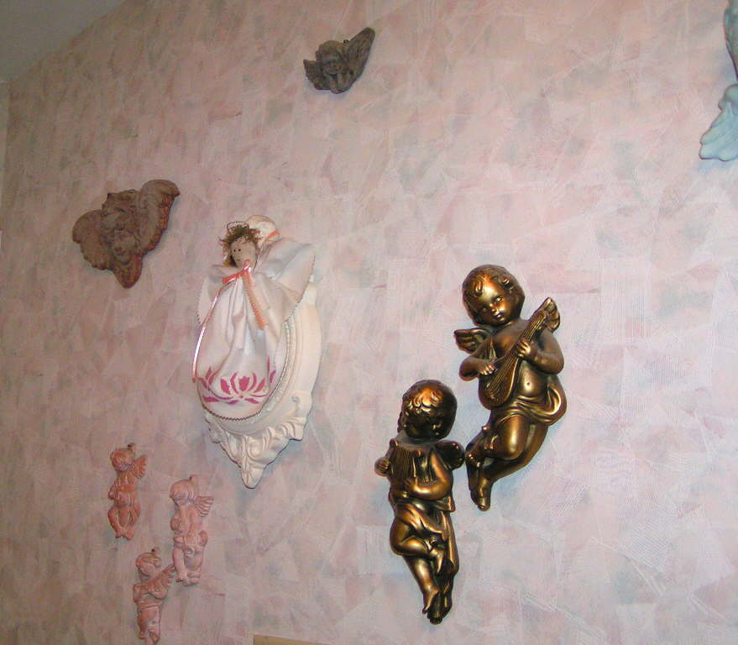
Sincerely,
Irene Vile

Yes, we can do it twice!!!!

Who Dat?!!!!

ENVISIONING POSSIBILITIES (new wallpaper)
EXECUTING PROCEDURES (just start rippin’)
ENCOURAGING PARTICIPATION
(beg Mark)

